Chapter 13

Exercise Solutions

Ex 13.1
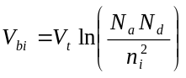
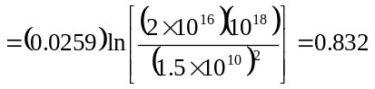V
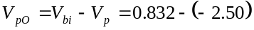
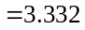V
Now
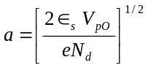
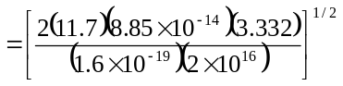
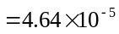cm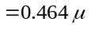m
_______________________________________

Ex 13.2
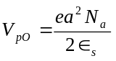
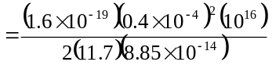
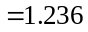V
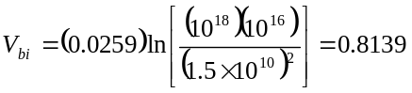V
V
_______________________________________

Ex 13.3
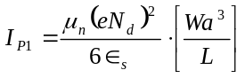
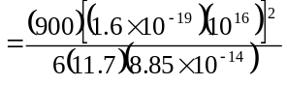
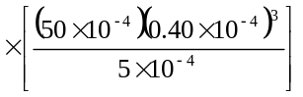
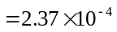A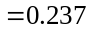mA
V

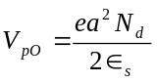
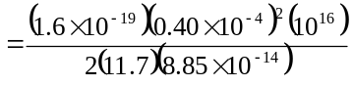
V
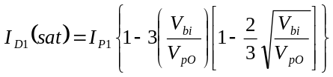
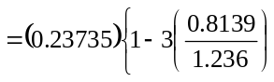
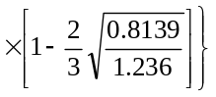
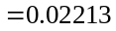mA
Or
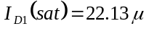A
_______________________________________

Ex 13.4
From Ex 13.3, 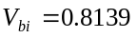V,
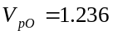V, 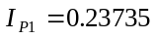mA
Then
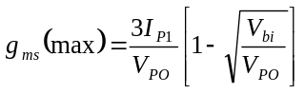
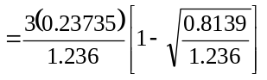
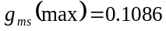mA/V
_______________________________________

Ex 13.5
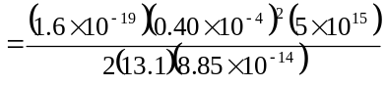
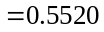V
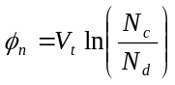
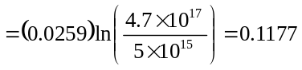V

V
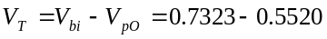
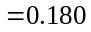V
_______________________________________

Ex 13.6
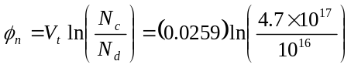
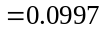V
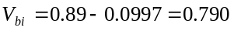V
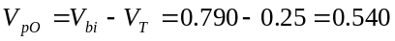V
Then
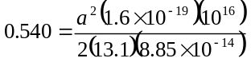
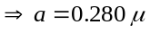m
_______________________________________

Ex 13.7
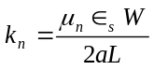
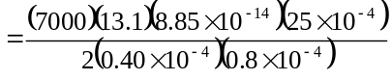
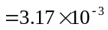A/V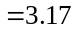mA/V
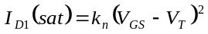
From exercise problem Ex 13.5,
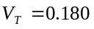V
Then
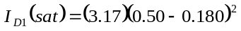
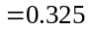mA
_______________________________________

Ex 13.8
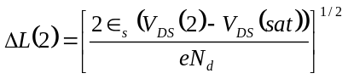
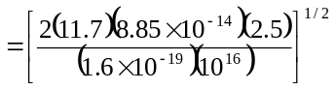
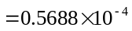cm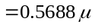m
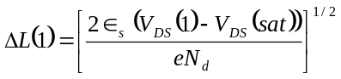
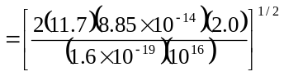
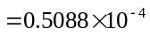cm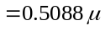m

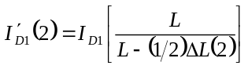
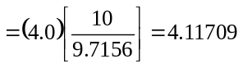mA
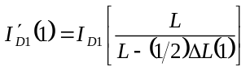
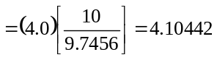mA
Now
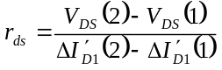
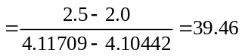k
_______________________________________

Ex 13.9
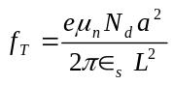
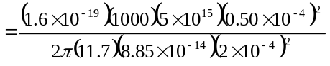
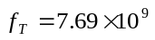Hz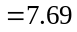GHz
_______________________________________

Test Your Understanding Solutions

TYU 13.1
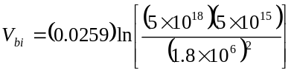
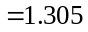V
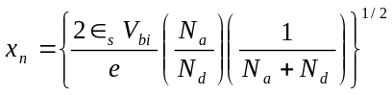
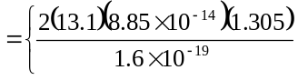
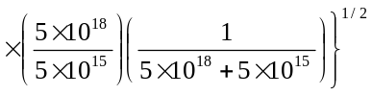
which yields
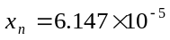cm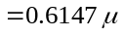m
We want
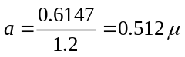m

So that
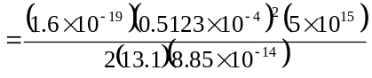
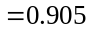V
Then
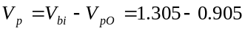
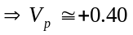V
_______________________________________

TYU 13.2
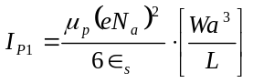
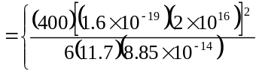
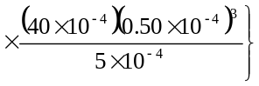
or 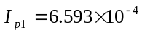A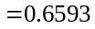mA
Now
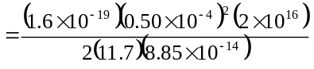
or 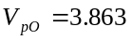V
Also
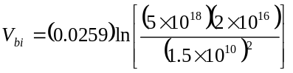
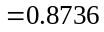V
Now
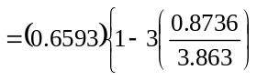
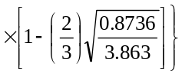
or 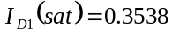mA
_______________________________________

TYU 13.3
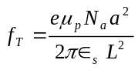
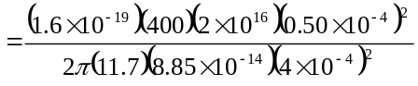
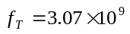Hz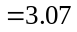GHz
_______________________________________

TYU 13.4
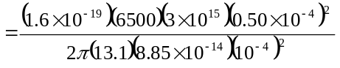
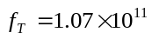Hz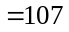GHz
_______________________________________

